|  |
| --- |
| Meeting the condition: Land Management Plans |
| Supporting Documents  June 2024 |

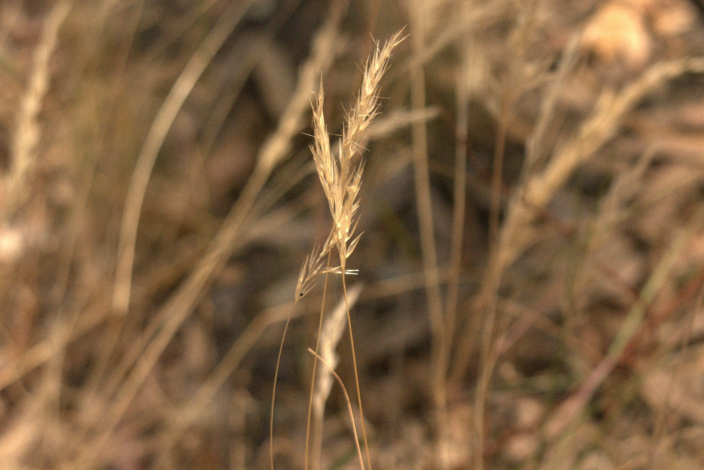

## Point based assessments

A point-based survey approach will apply the following:

* Undertake point-based vegetation assessments located at fixed points on a regular square grid. Depending on the type and size of property, these points should be separated by 40 – 80 m. The exact locations of the points should be recorded in a format suitable for display on a hand-held GPS or smartphone (see example in Figure 1)
* At each point, visually assess the cover of selected plant species groups (i.e. high threat weeds, native vegetation) roughly 10m around you in each direction. This area can be visualised without physically marking the plot. Plot data may be collected using an app or field sheet. This should list all the required plant groups and allow the surveyor to enter in their best estimate of the relevant cover. The estimates will be entered as any integer between 0 and 100, or 0.5 for very low covers
* Native vegetation condition is inferred through the combination of multiple assessed layers, considering cover and diversity
* Every point that falls within a target property should be assessed, regardless of where it falls. This applies even if a point falls outside native vegetation. Areas such as wetlands, cropland, yards, tracks, etc should all be assessed
* Surveyors should work as a group of two people for the first few plots (to assist calibration of cover estimates), then they may separate and undertake the plots individually, provided the two people are working within sight of each other.

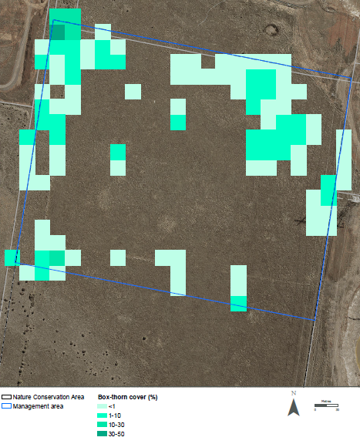 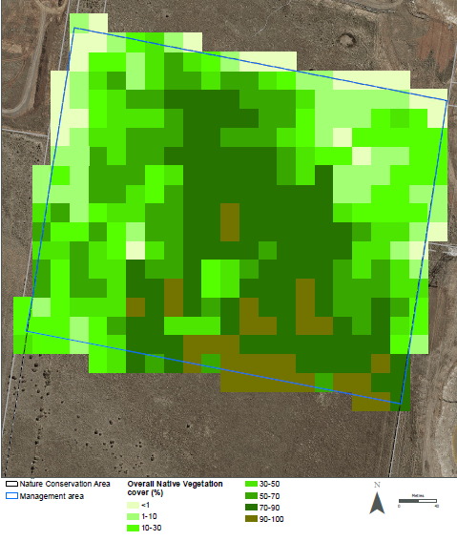

Figure 1. Example outputs of survey method for Native Vegetation (biodiversity value) and Box-thorn (threat to biodiversity) cover within a management plot intersecting a conservation area

## 2. Guidance on control methods for four broad weed types

Table 1. Tips for control methods based on broad weed types

|  |  |  |
| --- | --- | --- |
| **Weed type** | ***Example species*** | **Guidance** |
| Weeds which disperse seed through wind | *Serrated Tussock, Artichoke Thistle, Dandelion, Ragwort* | * Management should be timed to ensure control occurs prior to seed heads maturing, limiting ability to disperse |
| Woody weeds | *African Boxthorn, Gorse, Hawthorn, Spiny broom* | * Consider staging works to avoid erosion issues * Consider mechanical removal where appropriate |
| Perennial grassy weeds | *Chilean Needle Grass, Cane Needle Grass, Toowoomba Canary Grass* | * Biomass removal such as burning, mowing, slashing or brush cutting may be utilised to   + Aid herbicide application by reducing the likelihood of off target damage and reducing the amount of herbicide required   + Reduce flowering and seed set   + Expose young emergent grasses to herbivory from grazing animals * Mechanical removal of grassy weeds may be aided by prior herbicide application (i.e., initial spot spray tussocks for subsequent hand removal to reduce resident cleistogenes or reproductive material) |
| Tall flowering weeds | *Brassica, Twiggy Turnip, Bristly Ox-tongue* | * Mechanical removal such as mowing, slashing or brush cutting may be utilised to:   + Aid herbicide application by reducing the likelihood of off target damage and reducing the amount of herbicide required   + Reduce flowering and seed set * Avoid over clearing as these species are unlikely to be high threat ecologically and are likely a symptom of neglect and transition. Consider manual and integrated approaches rather than broad acre herbicide application |

## 3. Case studies

#### Nature Conservation

Consider a Nature Conservation grassland with several patches of remnant native vegetation. The largest or highest quality patches of native vegetation should be identified as first priority for weed control. Weeds should be managed in a way which avoids off-target impacts (see Table 1). This could be through a combination of targeted manual elimination of high threat weed species, alongside strategically timed ecological burns, which reduces biomass of widely distributed invasive species while favouring regeneration of natives. Burns may also promote natural regeneration of the seed bank and should be supplemented by planting were deemed necessary by active monitoring. Weed control can be more intensive where native vegetation is not present, however it should be ensured that a continuous treatment area does not exceed 400m2.

Weed control and complementary revegetation should be spatially prioritised around existing remnant patches of native vegetation and key species where possible. Once the objectives for the highest quality patches are achieved, subsequent work could prioritise creating habitat connectivity and improving the quality of other patches containing native vegetation (Figure 2).

|  |
| --- |
| Map showing patches of native grassland in a site with yellow arrows indicating linkages between the patches. The yellow arrows represent areas where weed management and revegetation should be focused to re-create connections between native vegetation patches. |
| Figure 2. Patches of remnant grasses linked via weed control and revegetation in areas marked with yellow arrows to assist connectivity and improve ecological outcomes |

A combination of supplementary planting and direct seeding of a simple native species mix (see Table 2) in controlled areas improves ecological outcomes while helping prevent recolonisation of invasive species. Species chosen should always be appropriate to the EVC and local conditions. C3 and C4 grass species should be clumped in clusters or patches to provide for management simplification including herbicide application. Parts of the conservation area outside of the identified priority areas must still be monitored and managed to prevent further growth and spread of weeds.

Table 2. Example revegetation composition based on grassland type

|  |  |
| --- | --- |
| Kangaroo Grass (*Themeda triandra)* dominated grassland | 80% *Themeda triandra* with remaining 20% consisting of a possible combination of Slender Wallaby-grass(*Rytidosperma racemosum*)*,* Bristly Wallaby-grass(*Rytidosperma setaceum*), Plains Spear-grass(*Austrostipa bigeniculata*), Slender Spear-grass (*Austrostipa scabra*) and Soft Spear-grass (*Austrostipa mollis*). These C3 grasses are to be planted in clusters/patches within the C4 dominated template.  C3 grasses such as Red-leg Grass (*Bothriochloa macra),* Windmill Grass (*Chloris truncata),* Silky Blue-grass (*Dicanthium sericeum*)and Bottlebrush grass (*Enneapogon nigricans*)could be used more broadly within this template particularly where specific habitat requirements for those species is present.  % of Wallaby or Spear grass can be reduced to include other grass species mentioned above or to include *Dianella spp.* And *Lomandra* *spp.* Ensuring C3 and C4 do not mix in a way it that impedes herbicide application techniques. |
| Spear-grass *(Austrostipa spp.)* / Wallaby-grass (*Rytidosperma spp.)* dominated grassland | 35% Wallaby-grass: Slender Wallaby *(Rytidosperma racemosum)*, Bristly Wallaby-grass (*Rytidosperma setaceum).* 45% Spear- grass: Slender Spear-grass (*Austrostipa scabra)* (dominant), Plains Spear-grass (*Austrostipa bigeniculata*) (second dominant) and Soft Spear-grass (*Austrostipa mollis)* (in clusters). The remaining 20% mix can contain some *Themeda* *triandra* or other grass species to be introduced in clusters where appropriate. |
| Common Tussock-grass (*Poa labillardierei*) dominated grassland | 90-95% Common Tussock-grass (*Poa labillardierei).* The remaining5-10% mix of other vegetation can consist of other grasses such as Long-hair Plume Grass *(Dichelachne rinite)* andCommon Wallaby- grass (*Rytidosperma caespitosum), Juncus spp., Carex spp.* |

#### GGF conservation area

Consider a conservation area containing a creek habitat corridor, a potential GGF wetland site and extensive terrestrial habitat up to the adjacent development interface. The majority of the site is made up of introduced grasses, with sections of shrubby and woody weeds. The main threat to GGF habitat values is overgrowth of dense weedy grasses on land that should be open foraging habitat.

The highest priority weeds for treatment are identified (Serrated Tussock, Variegated Thistle, Paterson’s Curse, Gorse and Hawthorn) and treated using best available methods (predominately herbicide with a view to incorporate ecological burns) to meet targets ranging from ≤1% to ≤10% cover.

Terrestrial habitat made up of non-invasive introduced grasses is to be maintained with periodic mowing and brush cutting once high priority weeds are treated. Eradication of these non-invasive species is not required. Direct seeding of native grasses and herbs is undertaken where vegetation cover has been reduced by weed removal to replace habitat and prevent re-growth of weeds. Native vegetation patches are protected and supported with targeted weed control. Preventing encroachment of exotic species into these areas is a priority.

Woody weeds pose a threat to GGF habitat and are to be treated via cutting and painting, with a second treatment of regrowth in Year 2. In terrestrial areas, some brush piles are to be retained as shelter sites for GGF. Native shrubs are to be planted where woody weeds are removed to offset loss of habitat and provide higher habitat variability for fauna.

A patchy arrangement of denser tussock-forming species is encouraged to maintain some potential terrestrial cover amongst open grassland. Supplementary revegetation is consistent with the EVC benchmark and the vegetation structure guidance within the [Growling Grass Frog Habitat Design Standards](https://www.msa.vic.gov.au/__data/assets/pdf_file/0019/73414/Growling-Grass-Frog-Habitat-Design-Standards_March2017.pdf).

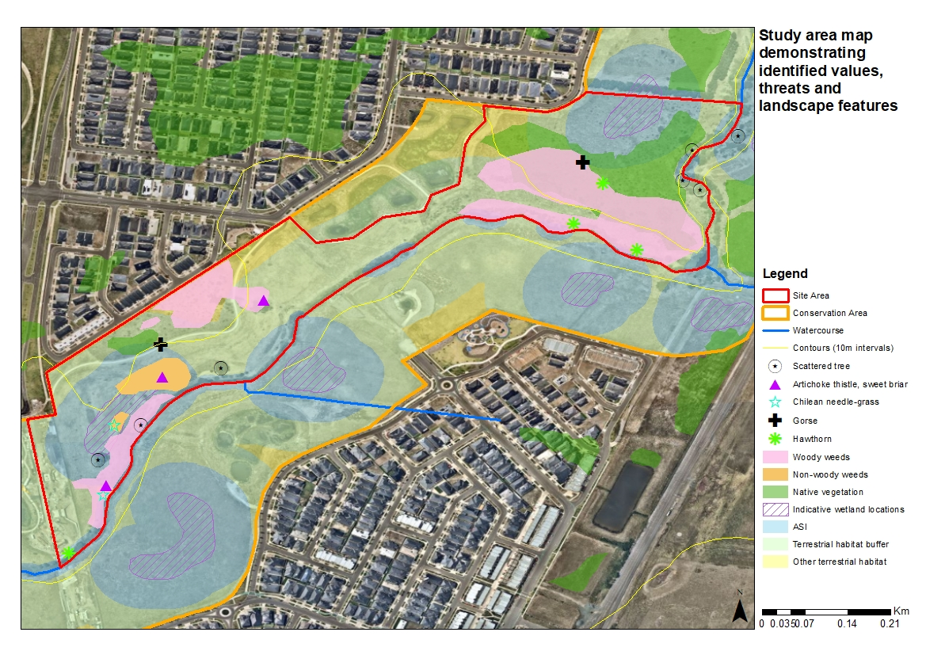

Figure 3. Example study area map demonstrating identified values, threats and landscape features

Rubbish (dumped or wind-blown from the adjoining development) and remnants of past land use (e.g. fencing, metal sheeting, concrete) are identified for removal. Farm fencing is to be removed by a suitable contractor, due to its potential to be a barrier and hazard for wildlife movement, land managers and the public. Rubbish is to be removed on foot, with regular inspections to be carried out and rubbish and hazards removed promptly.

## 4. Example management actions table

|  |  |  |  |  |
| --- | --- | --- | --- | --- |
| **Management action**  ***(e.g. weed control, monitoring)*** | **Management target**  ***(e.g. no rubbish in the conservation area, x% weed species cover, report submitted to DEECA)*** | **Responsible person**  ***(e.g. site manager, ecologist, contractor engaged by site manager)*** | **Proposed timeline**  ***(e.g. every x months as required, end of year x)*** | **Date completed**  ***(MM/YYYY)*** |
|  | **Year 1** | | | |
|  |  |  |  |  |
|  |  |  |  |  |
|  |  |  |  |  |
|  | **Year 2** | | | |
|  |  |  |  |  |
|  |  |  |  |  |
|  |  |  |  |  |
|  | **Year 3, 4, 5…** | | | |